Thank you for your interest in applying for a PMUNC Financial Aid (PFA) scholarship. PMUNC is committed to ensuring that students of all backgrounds can receive the educational benefits of competitive Model UN. The PFA Fund was established this year to further that objective.
Please submit this application to pmunc@princeton.edu as a single PDF titled “PMUNC2017_finaid_Firstname_Lastname.pdf” (e.g. “PMUNC2017_finaid_Andrew_Li.pdf”) with the subject line “PMUNC2017 Scholarship Application” by October 15, 2017. Please note that applications will be read and accepted on a rolling basis. If you have any questions, please contact pmunc@princeton.edu.

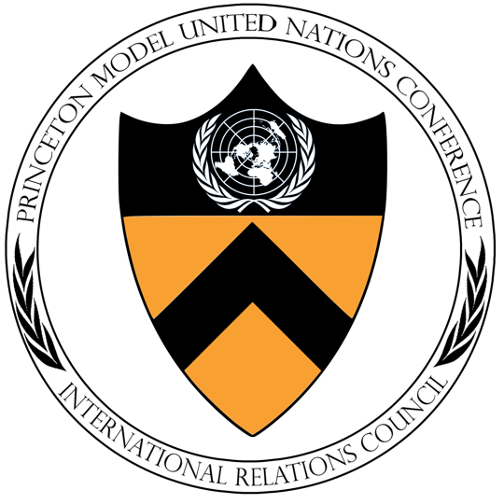
Terms and Conditions:
- Please only apply if you have significant financial barriers that prevent you from attending PMUNC. If at any point it is revealed that you have falsified documents, we retain the right to rescind your scholarship.
- Your application will remain strictly confidential and will not be shared with committee chairs, PMUNC staff, and all others who are not involved in scholarship admissions. Your application and/or scholarship will have no bearing on your participation or chance at receiving an award.
- We may receive more interested applicants than we can provide for. Financial aid is not guaranteed.
- If accepted to the scholarship program, international delegates will be provided funding after they secure visas, if applicable.
- You may apply as an independent delegate, but must have an adult chaperone accompany you at all times during the conference.
- You must stay at the Hilton East Brunswick, as the lodging portion of the scholarship will be provided as a hotel cost credit.
- Financial aid will cover the following costs: conference fees (including the delegate fee and the delegation fee for independent delegates), hotel stay, and meal plan. It will not cover transportation.
- We may be asking you to write a short blurb about yourself and your experience at PMUNC for our social media outlets (e.g. Facebook and Instagram) and website. If you do not consent to this, it will not affect your chances at receiving a scholarship.

Questions:
Name:
School:
Grade Year:
If domestic, State:
If international, Country (where you will be traveling from to PMUNC):
Do you need a visa?

If you are an independent delegate and under 18 years old, please provide the name, phone number, and email address of your adult chaperone.
Do you consent to allowing us to share a short publication about you and your PMUNC 2017 experience and a photo, both of which you may be requested to send to us, on our social media outlets (e.g. Facebook and Instagram) and website?

Please answer the following questions in 250 words or less.
QUESTION 1: Why would you like to attend PMUNC 2017? What do you expect to get out of this experience?

QUESTION 2: Do you have prior Model UN or debate experience? Please note that we do not expect you to have prior experience to apply for this scholarship.

QUESTION 3: Will you be seeking other sources of funding? (e.g. school alumni, Model UN club efforts, other sponsorships, etc.)

QUESTION 4: Is there anything you think will be helpful for us to know when considering your application?

Letter of Recommendation
Please ask your school’s Model UN club faculty advisor to e-mail us a letter of recommendation (approximately 250 words). Alternatively, you can ask a guidance counselor or teacher you know well. This letter should include the writer’s position, relationship to you, and speak to your specific candidacy for this scholarship.

