INSTRUCTIONS: Thanks for your interest in PMUNC 2018’s Japanese Imperialism: Shōwa Period. Please fill out this application and save your answers as a PDF named: “firstname_lastname_school_YC.” Applications are due October 3rd, 2018 and are to be emailed to aw35@princeton.edu.

NAME:
YEAR:
SCHOOL:
YEARS OF MUN EXPERIENCE:
Please rank your committee preference from highest to lowest (1 = top choice, 3 = last choice)
China __ Japan __ Korea __

QUESTION 1: What is your experience with Model United Nations in the past? Have you ever done any crisis committees before? What is the best moment you have had at a conference? If this is your first conference, what are you hoping to get out of this experience? (200 words maximum)

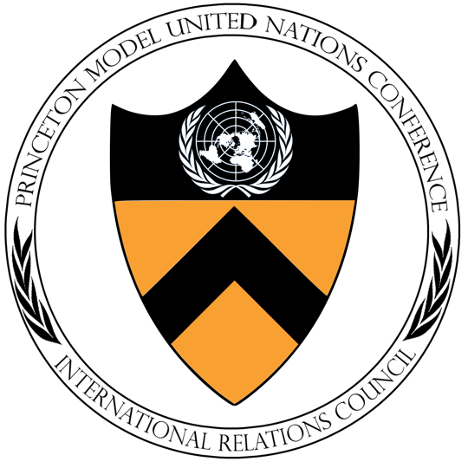
QUESTION 2: Describe a situation where you had to work with someone whose opinions differed from yours. How did you resolve the conflict? Is there anything you would have done differently? (200 words maximum)

QUESTION 3: East Asia is in turmoil. After half a century of struggles against Western empires, battles for political and economic dominance, and seismic domestic shifts, Korea, China, and Japan must make decisions that will change the shape and future of their nations, Asia, and the modern world. How should each nation address the challenges of nationalism, modernization, and expansionism?

QUESTION 4: What would be your second choice crisis committee? Are you willing to participate in another crisis committee if you would be a better fit there?

