INSTRUCTIONS: Thanks for your interest in PMUNC 2019’s Balkan Brawl. Please fill out this application and save your answers as a PDF named: “firstname_lastname_school_BALKAN.” Applications are due October 11th, 2019 and are to be emailed to jcurl@princeton.edu.

NAME:
YEAR:
SCHOOL:
YEARS OF MUN EXPERIENCE:

QUESTION 1: What is your experience with Model United Nations in the past? Have you ever done any crisis committees before? What is the best moment you have had at a conference? If this is your first conference, what are you hoping to get out of this experience? (200 words maximum)

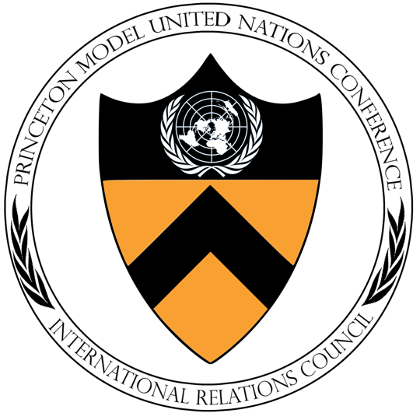
QUESTION 2: Describe a situation where you had to work with someone whose opinions differed from yours. How did you resolve the conflict? Is there anything you would have done differently? (200 words maximum)

QUESTION 3: The Arab Spring. The Syrian Civil War. To take a look at the complexities of Middle Eastern geopolitics, we turn back the clock to 1972, right before the Lebanese Civil War. It’s a civil war committee, what more can I say, but we ask the committee: was war really unavoidable? (400 words maximum)

QUESTION 4: What would be your second-choice crisis committee? Are you willing to participate in another crisis committee if you would be a better fit there?

